Android Screencast

Screencasting has two meanings.  Screencast used to mean "record your screen and a voice over to a file for later distribution."  In this modern era, Screencasting ALSO means "transmit the contents of your screen, real time, to a viewing device like a PC or a projector."

In order to do real-time screencasting, you need to have some software and hardware associated with the television that supports receiving screencasts, and some software and hardware on the device that supports transmitting screencasts.  
  
**Transmitting Side**  
  
To transmit a screen from an Android device, KitKat can use Koushik Dutta's Mirror or CyanogenMod CM11's Screencast which use the new screen recording capabilities in KitKat, but only for rooted devices.    
  
**Receiving Side**  
  
To receive the screencast from an screencasting device, a TV would need some kind of receiving device like a Chromecast or an AppleTV, depending on the screencasting protocol used.  Mirror seems to support transmitting to both a Chromecast and an AppleTV.

* Other options you may see are "Miracast" or PlayOn's "Playcast."  it is not clear if these receiving endpoints have a corresponding Android client.
* Additionally, there is also an Android app called "Cheapcast" that lets you take an old Android device and make it act as a Chromecast receiver.
* We cannot just wirelessly cast to a TV without adding a receiver, unless the TV itself has some kind of a built in receiver, like a SmartTV might.  As it stands, screencasting is not done through a universal protocol, so we need to be sure that your transmitter and receiver agree about how they will work together.

**How does Modern Era of Screencasting works-?**

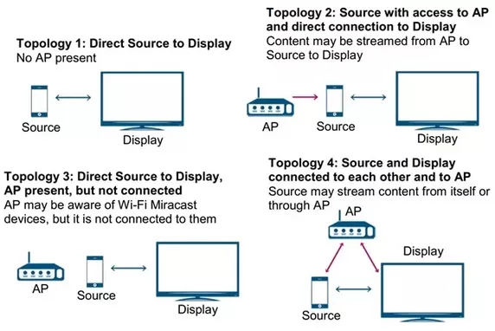

# Wired Methods

Back in the old days, turning your TV screen into a computer monitor was tantamount to sorcery. Nowadays, all you need is the right cable.

**[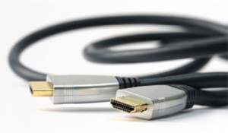](http://17c4dcd7f91259d8cc66-f5932f6db0039e8c02f89a70c334ff0e.r2.cf1.rackcdn.com/wp-content/uploads/sites/2/HDMI_2_0_banner.jpg)**

**HDMI:** If you’ve got yourself an HDMI-ready computer (desktop or laptop) and a TV with an HDMI port, you’re practically home free. All you need now is a cable to bridge the gap between. HDMI cables carry both HD video and audio signals, so there’s little more to it than connecting one end to your TV and the other end to your computer and change the input. It’s really that simple, which is probably why it’s one of the most ubiquitous connection standards.

Mobile Apple HDMI cables: You can also connect [Apple iPhones](http://www.notebookreview.com/phonereview/apple-iphone-6s-review/), iPod touches, and iPads to HDMI via Apple’s proprietary cables. The old 30-pin-to-HDMI will cost you $40 from Apple, while the Lightning-to-HDMI (also known as the Apple digital AV adapter) goes for around $50. Take heed: upgrading to iOS 8 and beyond has been reported to cause the 30-pin-to-HDMI method to cease functioning.

VGA: Depending on your particular needs, going the HDMI route may not be necessary. Most modern television sets are also equipped with VGA inputs that’ll turn your TV into the mother of all monitors. The only drawback here is that VGA delivers video only signals. That and VGA outputs aren’t found on new laptops. But as long as you aren’t relying on audio and using an older PC, connecting your computer with your TV with a VGA cable will do the job just fine.

DVI: Digital Video Interface (DVI) ports are also common on many older computers and HDTVs and can be used to make the connection, even if your television doesn’t have a DVI input port. All you’ll need in this case is a cable with DVI on one end and HDMI on the other. DVI has historically operated in much the same way as VGA, providing no audio support. In these situations, you would need to run an audio cable from your computer to your TV. However, success in transmitting both video and audio via DVI can depend on how your soundcard is configured.

[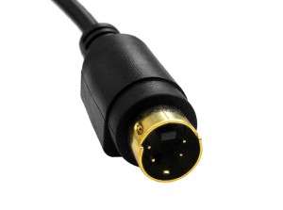](http://17c4dcd7f91259d8cc66-f5932f6db0039e8c02f89a70c334ff0e.r2.cf1.rackcdn.com/wp-content/uploads/sites/2/800px-S-video-connection.jpg)

S-Video: S-Video outputs are circular with anywhere from four to nine pins. Taking this route delivers a slightly more limited experience. S-Video is analog, not HD, and also doesn’t carry audio signals, but it can be made to work with the right kinds of cables and adapters. If you’re using an older TV set that doesn’t offer HD resolution, S-Video is your best bet. Even if your TV set doesn’t have an S-Video input port, you can buy an S-Video-to-RCA cable that’ll plug straight into your old dinosaur’s RCA video jack. For sound, use the same methods described for VGA and DVI.

# Wireless Methods

Mirroring is the act of connecting your computer, laptop or mobile device to your TV minus the wires. Historically, this has been a little tricky thanks to numerous competing standards and device-specific branding, like Samsung’s Allshare and LG’s Smart Share, which both use the Miracast standard under a different name. Newer smartphone models show evidence that manufacturers are moving away from device-specific branding and are making things easier by identifying which one of the two principal standards their units support: Miracast or Chromecast.

[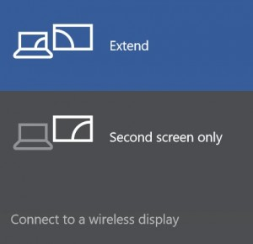](http://17c4dcd7f91259d8cc66-f5932f6db0039e8c02f89a70c334ff0e.r2.cf1.rackcdn.com/wp-content/uploads/sites/2/miracast.jpg)

**Miracast**: Miracast can best be described as a wireless HDMI connection. The big difference that separates Miracast from its main competitor Chromecast is that it doesn’t require the use of a central router to bridge the connection between your mobile device and your HDTV. It doesn’t even require an internet connection at all. Instead, it uses the Wi-Fi Direct protocol to transmit 1080p video and 5.1 surround sound. It’s also cross-platform, which means it will work across different brands of electronics as long as they are Miracast certified, and is secured by WPA2 encryption.

Miracast comes standard on all devices running Windows 8.1, and [Android mobile devices](http://www.notebookreview.com/feature/samsung-galaxy-note5-vs-samsung-galaxy-s6-edge-vs-motorola-moto-x-pure-edition/) running Jelly Bean 4.2 or later – although having 4.2 installed on your older Android doesn’t necessarily mean your device is capable of mirroring content. Miracast functionality is a built-in standard with all Android devices manufactured with 4.4 and later. Most late-model Intel computers and laptops are also Miracast enabled, often under the Intel WiFi certification. Amazon’s Fire OS is also supported by Miracast. The [Wi-Fi Alliance website](http://www.wi-fi.org/product-finder) provides information on all products that support the standard.

In order for a Miracast screen cast to work, both the sending and receiving device have to be Miracast certified. If the HDTV you want to mirror to isn’t Miracast-certified, there are viable workarounds that won’t require you to trade in for a new television set. These include Miracast dongles (AKA streaming sticks) and set-top boxes that offer you a bit more navigation functionality.

[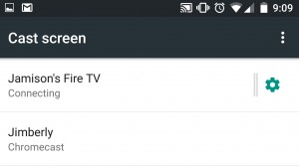](http://17c4dcd7f91259d8cc66-f5932f6db0039e8c02f89a70c334ff0e.r2.cf1.rackcdn.com/wp-content/uploads/sites/2/Screenshot_2015-10-23-09-09-26.jpg)

You can find Miracast dongles from Roku, Microsoft, Belkin, and Asus in the price range of $50 to $60. Additionally, Amazon’s Fire TV stick can be purchased for around $40, but the drawback is that it only supports mirroring from Android and doesn’t work with Windows devices.

If you prefer a bit more functionality, there are set-top boxes you can buy that will bridge the communication gap between your Miracast-enabled mobile device and non-Miracast HDTVs. Among the most popular and widely used are the Amazon Fire TV and Roku streaming box, which can run you between $90 and $130. The Xbox One now also supports Miracast for Android, Windows Phone and Windows PCs.

One of the notable limitations of using Miracast to screen cast from your mobile device is that you’ll have to keep your smartphone or tablet awake in order to continue the stream. This can quickly drain your mobile device’s battery and may require you to remain plugged in and charging when streaming data to your HDTV.

[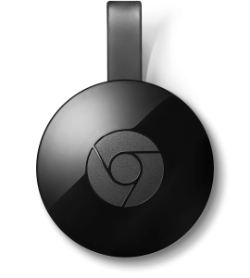](http://17c4dcd7f91259d8cc66-f5932f6db0039e8c02f89a70c334ff0e.r2.cf1.rackcdn.com/wp-content/uploads/sites/2/chromecast.png)

[Chromecast](https://www.google.com/chromecast/tv/): For an investment of $35, you can buy a Chromecast dongle that connects to your HDTV’s HDMI port and turns just about any device — Windows, Apple or Android — into a virtual broadcasting hub. All you have to do is dial the dongle into your Wi-Fi network and you’re ready to go. Chromecast is currently functional with a growing number of supporting apps, including Netflix, YouTube, HBO Now, Hulu Plus, Pandora, Google Play, and Google Chrome browser tabs, the latter of which could be ideal for turning your entertainment center into a workplace productivity center, especially after you throw in the Google Drive functionality. Chromecast also enables Android display mirroring on many Android smartphones released since mid-2013.

The big difference that separates Chromecast from Miracast is the requirement to have an active internet connection streaming through a central router in order to mirror content from your mobile device. One of the benefits that Chromecast has over Miracast is that once streaming from your mobile device begins, you can use your broadcasting device for other purposes – unlike with Miracast, where mirroring only continues as long as both devices are engaged.

Chromecast supports Android devices running Chrome OS, Jelly Bean 4.1 or later, iOS 7.0 or later, Windows 7 or later, and Mac OS X 10.7 or later.

[Apple AirPlay](https://support.apple.com/en-us/HT204289): If you’ve got an iPhone 4S (or later),[iPad 2](http://www.tabletpcreview.com/tabletreview/apple-ipad-air-2-review/) (or later), iPad mini, fifth-generation iPod touch, or [MacBook](http://www.notebookreview.com/notebookreview/apple-macbook-review-12-inch-2015-model/) from 2011 or later, you can connect to your TV without the need for bothersome cables. There is one easy way to do this, and that’s with an Apple TV device. This method is nearly pain free, and is an example of that old Apple strength of products that “simply work.” Unfortunately, it’s limited to Apple

**Protocols, which mobile devices uses to stream its screen (data) to TV/Reciever over wireless connections –**

* **Universal Plug and Play (UPnP)** is a set of networking protocols that permits networked devices, such as personal computers, printers, Internet gateways, Wi-Fi access points and mobile devices to seamlessly discover each other's presence on the network and establish functional network services for data sharing, communications, and entertainment. UPnP is intended primarily for residential networks without enterprise-class devices.
* UPnP extends plug and play—a technology for dynamically attaching devices directly to a computer—to zero configuration networking for residential and SOHO wireless networks. UPnP devices are "plug and play" in that, when connected to a network, they automatically establish working configurations with other devices.
* **UPnP MediaServer ControlPoint** - which is the UPnP-client (a 'slave' device) that can auto-detect UPnP-servers on the network to browse and stream media/data-files from them.
* **UPnP RenderingControl DCP** - control MediaRenderer settings; volume, brightness, RGB, sharpness, and more.
* **UPnP Remote User Interface (RUI) client/server** - which sends/receives control-commands between the UPnP-client and UPnP-server over network, (like record, schedule, play, pause, stop, etc.).
* **DLNA** is derived from UPnP, as an attempt to normalize media interoperability. It does this partly by being more restrictive than UPnP (e.g. by restricting the number of media formats) and partly by adding features (like DRM, i.e. copy protection).

**DLNA** on the other hand does not concentrate to upnp standards, it places requirements to ALL standards that are being used. Upnp AV happens to be one of those standards, but included are others, for instance:

* Media (ensuring media in devices is compatible, and devices recognise is media compatible instead of trying and failing)
* Media servers (exact requirements to HTTP headers and timeouts)
* We can actually call from one phone to another and have a conversation